**SPH3U 12.1 Magnetic Fields**

1. **Magnetic fields**

|  |  |
| --- | --- |
| Magnets: |  |
| Magnetic field: |  |
| direction |  |
| magnetic field lines |  |

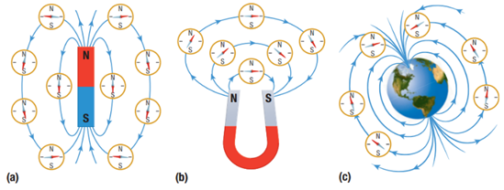

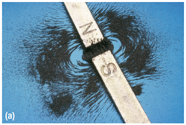 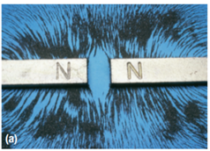

Draw a bar magnet (north and south poles) and its magnetic field lines, including compass indications of the direction of the field at various points.

**Homework:** page 552: #5-6